Algorithm - First program : step2

Objective :
Create a simple program and use conditional instructions.

Practical work
- Start DELPHI
- Open the last project (ADNA_1st. If necessary open the correction) : Fichier/Ouvrir un projet
- Save it as ADNA_2nd.
- Complete the grid below
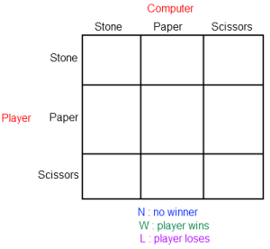
- Program the game’s engine
- Hint 1 : The computer’s random value is generated by the command
randomize;
computer:= random(3);
where computer is an integer
In this case, the possible values for computer are 0, 1 or 2...
- Hint 2 : To convert a character into an integer, use the instruction strtoint.
Example : player:=strtoint(choice);
- Hint 3 : To convert an integer into a string, use the instruction inttostr
Example : writeln(inttostr(computer));

