Algorithm - First program

Objective :
Create a simple program and use the first I/O instructions.
Start the programming of the first game.

Practical work
- Start DELPHI
- Create a new project : Fichier/Nouveau/Autre/Application Console
- Save it as ADNA_1st in an accessible disk space
- Copy/paste the text bellow in the source code.
program ADNA1;
{$APPTYPE CONSOLE}
uses
SysUtils;
procedure exit_app;
var quit:char;
begin
WriteLn('>> Type Q to quit <<');
repeat
readln(quit);
until quit='Q';
end; //de quitter
begin
//--------------- place your code here ---------------------------------------
//----------------------------------------------------------------------------
Exit_app ;
end.
- WRITE is the command to write a text on the screen.
For ex : Write(‘Hello’);
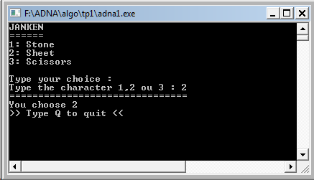
Activity : Write your name on the screen and test the program. Call your teacher
- READ is the command to get a keyboard input.
For ex : read(name); The text typed on the keyboard will be placed in the variable name.
Activity : Change the previous program so that it requires your name and write it on the screen
- Write the first function of the game Janken : get a number displayed on the screen (1: stone, 2:sheet, 3:scissors); Display this number on the screen.

